Video link - NLP final project part-B

Part B : News Article Classification

REPORT

Step-1: environment
Loaded all the libraries and stopwords

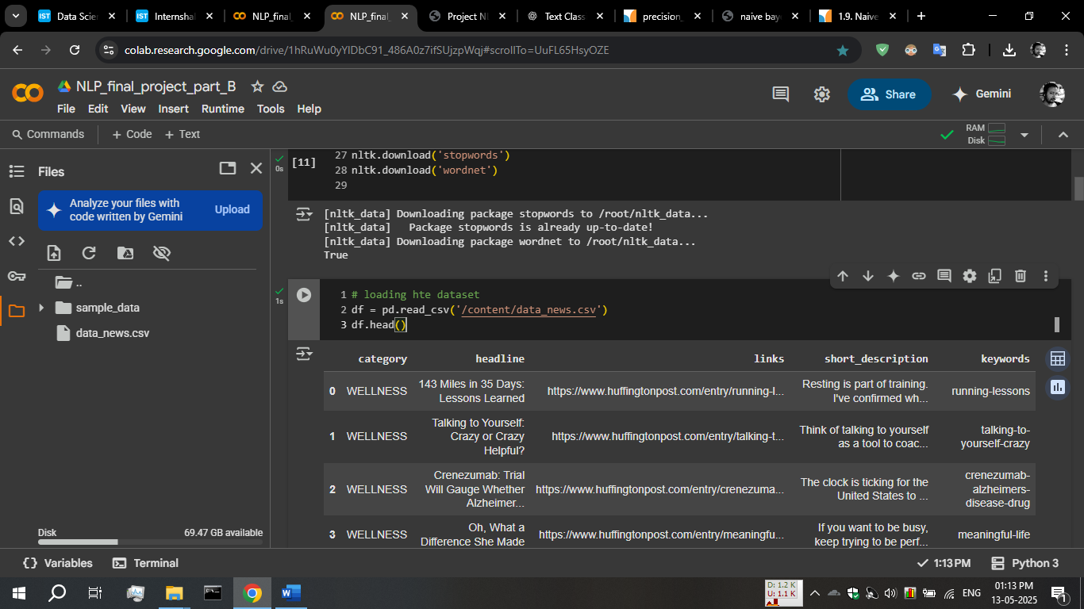
Step-2: loading the dataset

I used colab upload option to load the data ,
and then read_csv function of pandas to reaed the file content.

Step-3: test pre-processing
First I removed the rows containg null values using dropna function
df = df.dropna(axis=0)

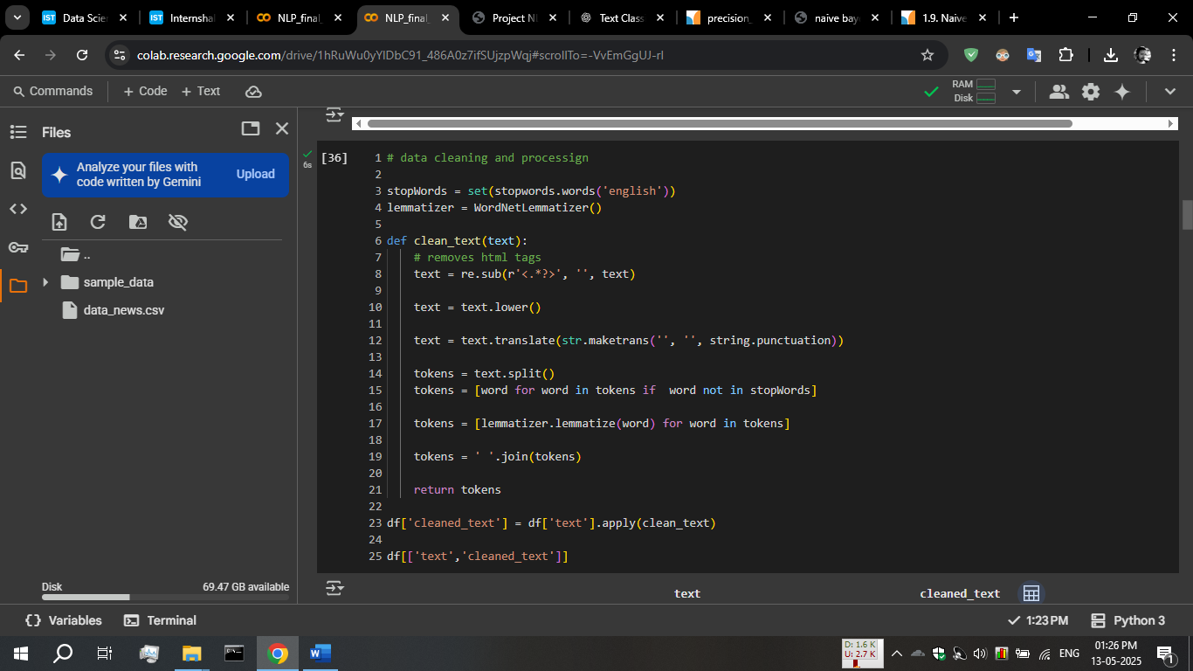

our dataset containing many text columns, so I combined them into one
df['text'] = df['keywords'] + ' ' +df['headline'] + ' ' + df['short_description']

then for cleaning
I used regular expressions to remove html tags, then maketrans and translate function to remove any punctuation and stop words
After it we apply lemmatization
Data after cleaning in cleaned_text column
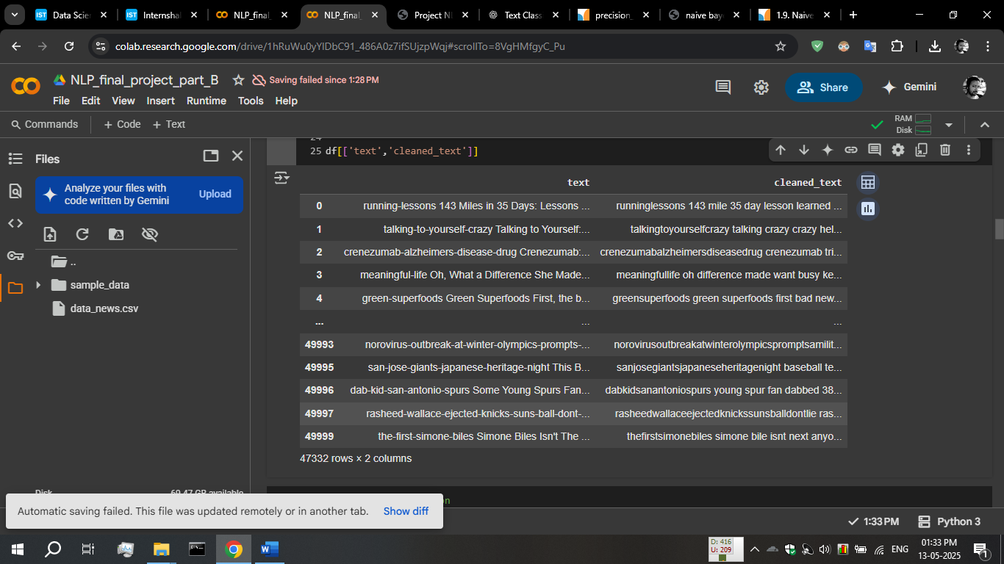

Step 4: feature extraction and vectorization
I used TfidfVectorizer class from sklearn.feature_extraction.text,

tfidf = TfidfVectorizer(max_features=2000)
X = tfidf.fit_transform(df['cleaned_text'])
print(X)
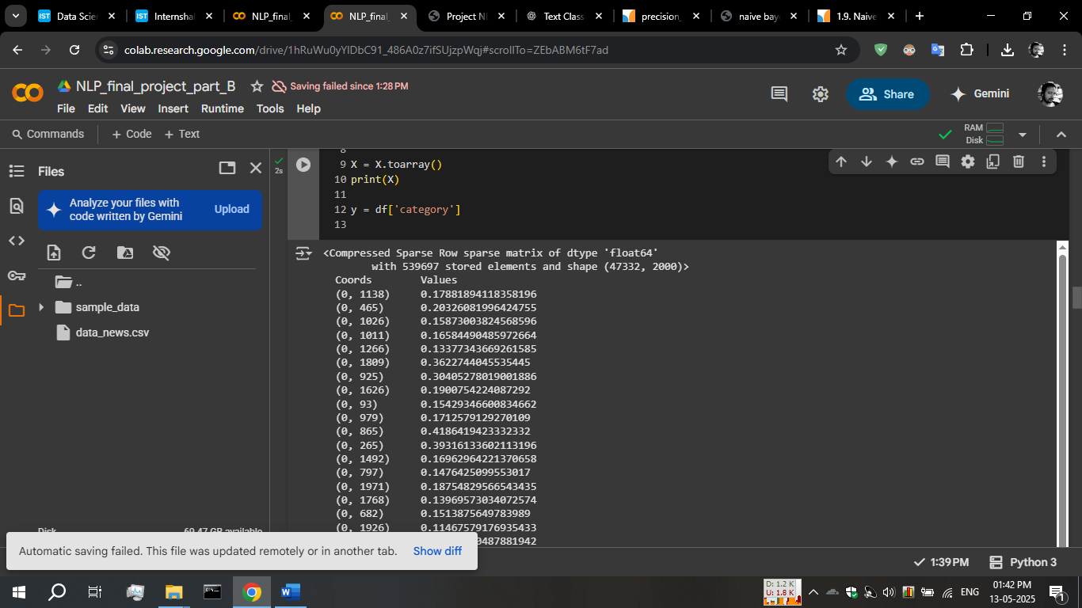
outputs this

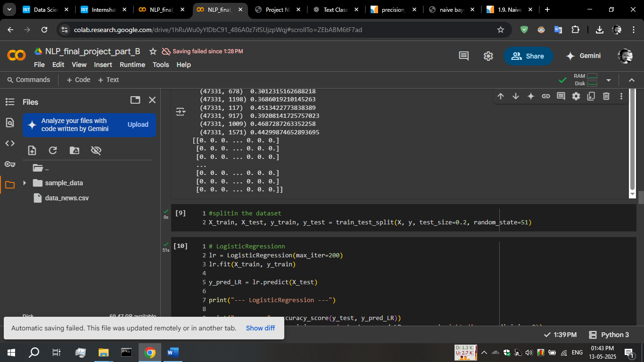
After toarray(),

Step -4 : training the model
I use LogisticRegression, naive bayes – MultinomialNB , SVC-linear model for training

# LogisticRegressionn
lr = LogisticRegression(max_iter=200)
lr.fit(X_train, y_train)
y_pred_LR = lr.predict(X_test)
# naïve bayes - MultinomialNB - it is used for word classification
nb = MultinomialNB()
nb.fit(X_train, y_train)
y_pred_NB = nb.predict(X_test)

# LinearSVC
svc = LinearSVC()
svc.fit(X_train, y_train)
y_pred_SVC = svc.predict(X_test)

I trained all models with same training and test data

Step-5: evaluating the models
All model preforming well, logisticRegression is better in all of them

--- LogisticRegression ---
accuracy: 0.8163092848843351
precision: 0.817225583855853
recall: 0.8163092848843351
f1 score: 0.816550059427474
report:
precision recall f1-score support

BUSINESS 0.80 0.78 0.79 901
ENTERTAINMENT 0.80 0.80 0.80 956
FOOD & DRINK 0.87 0.88 0.87 967
PARENTING 0.79 0.78 0.79 899
POLITICS 0.77 0.75 0.76 906
SPORTS 0.90 0.89 0.90 989
STYLE & BEAUTY 0.90 0.86 0.88 953
TRAVEL 0.79 0.79 0.79 974
WELLNESS 0.74 0.80 0.77 944
WORLD NEWS 0.82 0.81 0.81 978

accuracy 0.82 9467
macro avg 0.82 0.82 0.82 9467
weighted avg 0.82 0.82 0.82 9467

--- naive bayes ---
accuracy: 0.8025773740361255
precision: 0.80599239191142
recall: 0.8025773740361255
f1 score: 0.8032511411590265
report:
precision recall f1-score support

BUSINESS 0.80 0.73 0.77 901
ENTERTAINMENT 0.82 0.78 0.80 956
FOOD & DRINK 0.84 0.88 0.86 967
PARENTING 0.70 0.77 0.73 899
POLITICS 0.80 0.75 0.78 906
SPORTS 0.91 0.86 0.88 989
STYLE & BEAUTY 0.90 0.81 0.85 953
TRAVEL 0.75 0.80 0.78 974
WELLNESS 0.73 0.80 0.76 944
WORLD NEWS 0.79 0.83 0.81 978

accuracy 0.80 9467
macro avg 0.80 0.80 0.80 9467
weighted avg 0.81 0.80 0.80 9467

--- LinearSVC ---
accuracy: 0.8155698743002007
precision: 0.8156090760570802
recall: 0.8155698743002007
f1 score: 0.8153909932571692
report:
precision recall f1-score support

BUSINESS 0.80 0.83 0.82 901
ENTERTAINMENT 0.81 0.79 0.80 956
FOOD & DRINK 0.85 0.86 0.86 967
PARENTING 0.77 0.78 0.77 899
POLITICS 0.79 0.76 0.77 906
SPORTS 0.89 0.93 0.91 989
STYLE & BEAUTY 0.89 0.85 0.87 953
TRAVEL 0.79 0.77 0.78 974
WELLNESS 0.76 0.78 0.77 944
WORLD NEWS 0.80 0.80 0.80 978

accuracy 0.82 9467
macro avg 0.81 0.81 0.81 9467
weighted avg 0.82 0.82 0.82 9467

Thank you

